Update on Cambridge University Brain Imaging Research
October 2022

Dear autism community,

We are a research team at the University of Cambridge led by Dr. Alex Woolgar. Our team is interested in how non-speaking autistic people understand spoken language. We would like to study this using brain imaging. In this short newsletter, we want to inform people on where the research is up to, and ask autistic non-speakers for feedback and input on our research plans.

What inspired our research?
Dr Woolgar became interested to study the abilities of non-speaking autistic people after working with a 6-year-old child using the Rapid Prompting Method (RPM). The child, we’ll call her Lucy (not her real name), didn’t speak yet at that time, but through RPM she showed that she was smart, imaginative and thoughtful. The experience changed Dr Woolgar’s understanding of how well Lucy understood spoken language and made her question the scientific understanding of autism – which frequently assumes that children who do not speak also do not understand.

What are the main goals of the research?
We would like to learn more about how non-speaking peoples’ brains processes spoken words, using brain imaging technologies that are gentle and fast to set up. The aim of our research is to provide a chance for non-speaking autistic people to demonstrate how well they understand word meanings without relying on speech or behaviour. We hope to achieve this by creating suitable, reliable brain imaging measures that can be used as a marker of language processing.

Research preparation
The very new approach taken in this research – using brain imaging to look at information processing in the brain – has taken a few years to develop. We spent 5 years preparing the study, which involved working with typically developing children and their families, as well as with a few RPM students, to develop child-friendly paradigms, the most suitable brain imaging technologies, and sensitive analytical methods for the research. We have had 3 peer-reviewed papers on this preparative work published in scientific journals.

What is the research method?
We are using Electroencephalography (EEG) which uses electrodes on the scalp to measure the tiny electrical impulses caused by neurons firing in the brain. We record these tiny signals while people listen to spoken words and sentences. By comparing the brain responses to sentences that do and do not make sense, we seek to detect brain responses that reflect understanding language.

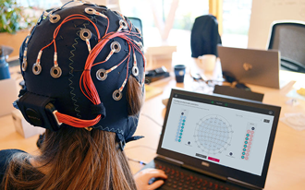
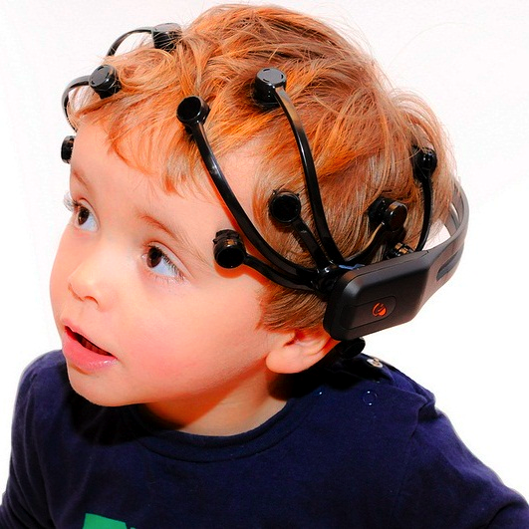

Examples of two different headsets we use to record brain activity. Pictures from manufacture’s website.

Update October 2022
Thanks to the overwhelmingly positive response from minimally-verbal autistic individuals and their families, we have now collected 71 sessions of EEG recordings from 24 autistic individuals in the UK and Ireland. We are extremely grateful to all the individuals who gave us their time to participate in our study. We have now paused data collection while we work on data analysis. However we hope to design follow-up experiments and will start recruiting participants again in 2023.

What happens next?
The next step will be to analyse all the data collected in autistic individuals, to establish whether our brain imaging approach can be used effectively or needs to be modified. We will then publish the results in the form of an academic article, and summarise them on our website (www.woolgarlab.org). We hope to complete this in 2023. Depending on the results of the study so far, we may continue using a similar design and technology, or create different experiments that will help us understand better how the brain of autistic people work. Our aim remains to find a suitable way to study receptive language processing in autistic individuals who do not speak, or speak unreliably.

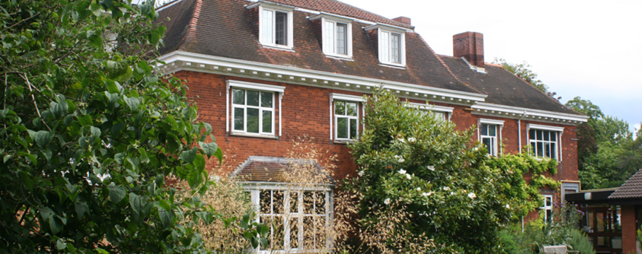

The MRC Cognition and Brain Sciences Unit in Cambridge

We would like to hear from you. Here are our questions.
Please fill in your responses under each question and email them to Selene.Petit@mrc-cbu.cam.ac.uk

Question 1. Describe the ways in which you yourself communicate. How would you characterise your spoken language?

Question 2. What makes communication easy or hard for you?

Question 3. What do you anticipate might be the challenges of participating in brain imaging research? If you were designing the research protocol what would your method look like?

Question 4. What would you like to tell researchers and scientists – that they might not realise - about how your brain and body works to communicate?

Question 5. What would you like researchers in Cambridge to study, in the future, about the brains of non-speakers? Why?

Question 6. Would you yourself be interested to take part in brain imaging research? Why/Why not?

Question 7. Please tell us:
- How many years old are you?
- What state/county and country do you live in?

Question 8. Parents and communication partners, do you have any comments you would like to share?

We hope that you are all staying safe, happy and healthy.

Dr. Alex Woolgar and Dr. Selene Petit
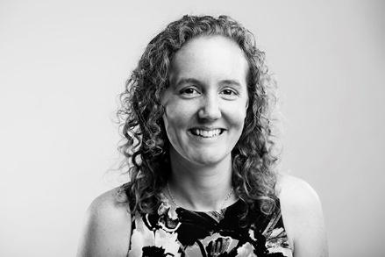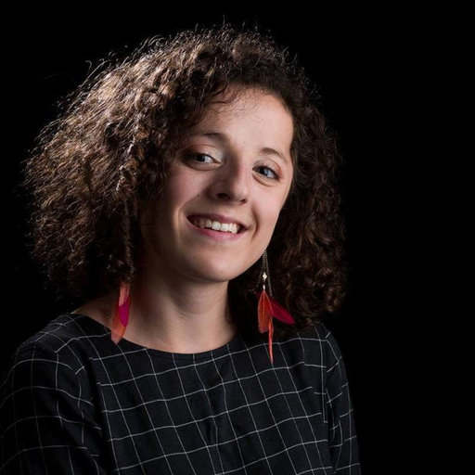

www.woolgarlab.org

